// Splitting a PDF in to many using Java

import org.apache.pdfbox.multipdf.Splitter;

import org.apache.pdfbox.pdmodel.PDDocument;

import java.io.File;

import java.io.IOException;

import java.util.List;

import java.util.Iterator;

public class SplitPdf {

public static void main(String[] args)

throws IOException

{

// Loading PDF

File pdffile

= new File("C:/Desktop/Java/sample.pdf");

PDDocument document = PDDocument.load(pdffile);

// Splitter Class

Splitter splitting = new Splitter();

// Splitting the pages into multiple PDFs

List<PDDocument> Page = splitting.split(document);

// Using a iterator to Traverse all pages

Iterator<PDDocument> iteration

= Page.listIterator();

// Saving each page as an individual document

int j = 1;

while (iteration.hasNext()) {

PDDocument pd = iteration.next();

pd.save("C:/Desktop/Java/Generated/sample-"

+ j++ + ".pdf");

}

System.out.println("Splitted Pdf Successfully.");

document.close();

}

}

Before execution of program

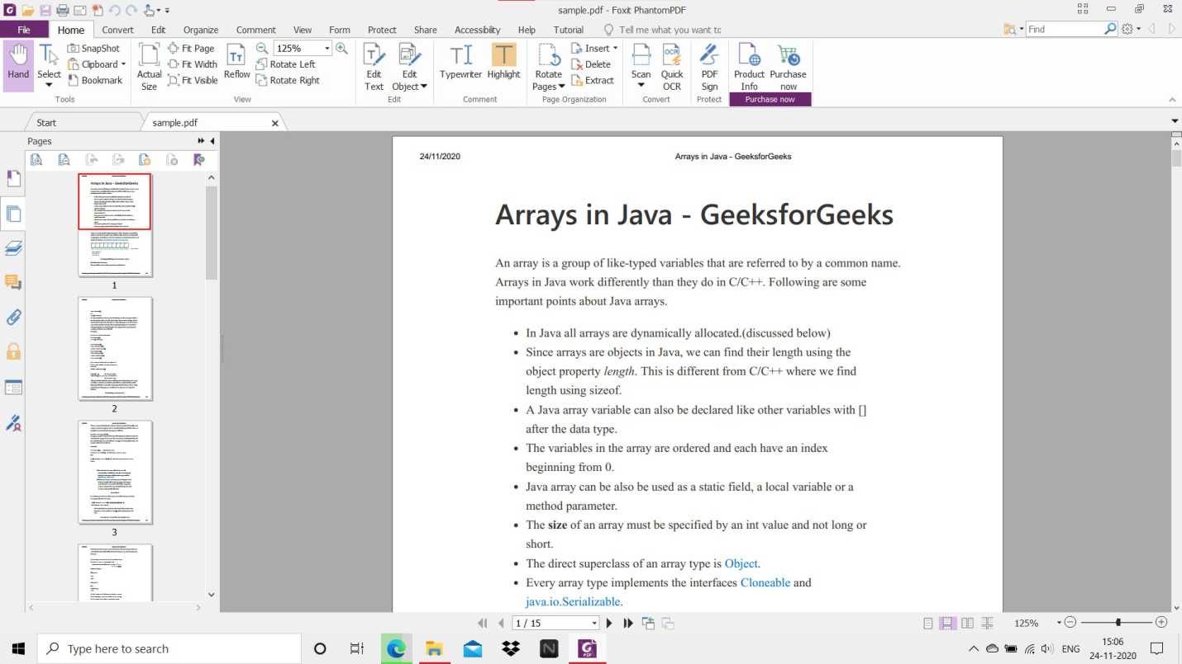

After execution of program

